A computer network is a set of devices connected through links. A node can be computer, printer, or any other device capable of sending or receiving the data. The links connecting the nodes are known as communication channels.

Computer Network uses distributed processing in which task is divided among several computers. Instead, a single computer handles an entire task, each separate computer handles a subset.

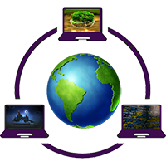

Following are the advantages of Distributed processing:

* **Security:** It provides limited interaction that a user can have with the entire system. For example, a bank allows the users to access their own accounts through an ATM without allowing them to access the bank's entire database.
* **Faster problem solving:** Multiple computers can solve the problem faster than a single machine working alone.
* **Security through redundancy:** Multiple computers running the same program at the same time can provide the security through redundancy. For example, if four computers run the same program and any computer has a hardware error, then other computers can override it.

# **What is a Computer Network?**

* **Computer Network** is a group of computers connected with each other through wires, optical fibres or optical links so that various devices can interact with each other through a network.
* The aim of the computer network is the sharing of resources among various devices.
* In the case of computer network technology, there are several types of networks that vary from simple to complex level.

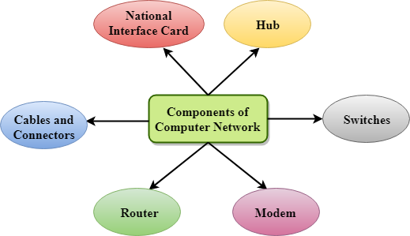

## **Major components of a computer network are:**

### NIC(National interface card)

NIC is a device that helps the computer to communicate with another device. The network interface card contains the hardware addresses, the data-link layer protocol use this address to identify the system on the network so that it transfers the data to the correct destination.

There are two types of NIC: wireless NIC and wired NIC.

* **Wireless NIC:** All the modern laptops use the wireless NIC. In Wireless NIC, a connection is made using the antenna that employs the **radio wave technology**.
* **Wired NIC:** Cables use the **wired NIC** to transfer the data over the medium.

### Hub

Hub is a central device that splits the network connection into multiple devices. When computer requests for information from a computer, it sends the request to the Hub. Hub distributes this request to all the interconnected computers.

### Switches

Switch is a networking device that groups all the devices over the network to transfer the data to another device. A switch is better than Hub as it does not broadcast the message over the network, i.e., it sends the message to the device for which it belongs to. Therefore, we can say that switch sends the message directly from source to the destination.

### Cables and connectors

Cable is a transmission media that transmits the communication signals. **There are three types of cables:**

* **Twisted pair cable:** It is a high-speed cable that transmits the data over **1Gbps** or more.
* **Coaxial cable:** Coaxial cable resembles like a TV installation cable. Coaxial cable is more expensive than twisted pair cable, but it provides the high data transmission speed.
* **Fibre optic cable:** Fibre optic cable is a high-speed cable that transmits the data using light beams. It provides high data transmission speed as compared to other cables. It is more expensive as compared to other cables, so it is installed at the government level.

### Router

Router is a device that connects the LAN to the internet. The router is mainly used to connect the distinct networks or connect the internet to multiple computers.

### Modem

Modem connects the computer to the internet over the existing telephone line. A modem is not integrated with the computer motherboard. A modem is a separate part on the PC slot found on the motherboard.

## **Uses Of Computer Network**

* **Resource sharing:** Resource sharing is the sharing of resources such as programs, printers, and data among the users on the network without the requirement of the physical location of the resource and user.
* **Server-Client model:** Computer networking is used in the **server-client model**. A server is a central computer used to store the information and maintained by the system administrator. Clients are the machines used to access the information stored in the server remotely.
* **Communication medium:** Computer network behaves as a communication medium among the users. For example, a company contains more than one computer has an email system which the employees use for daily communication.
* **E-commerce:** Computer network is also important in businesses. We can do the business over the internet. For example, amazon.com is doing their business over the internet, i.e., they are doing their business over the internet.

// link to the architecture of the network.

https://www.javatpoint.com/computer-network-architecture

# **Features Of Computer network**

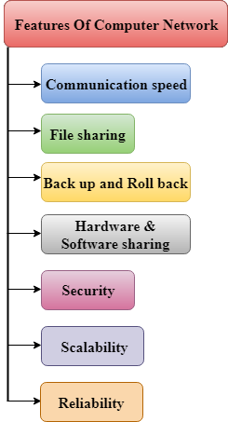

A list Of Computer network features is given below.

* Communication speed
* File sharing
* Back up and Roll back is easy
* Software and Hardware sharing
* Security
* Scalability
* Reliability

### Communication speed

Network provides us to communicate over the network in a fast and efficient manner. For example, we can do video conferencing, email messaging, etc. over the internet. Therefore, the computer network is a great way to share our knowledge and ideas.

### File sharing

File sharing is one of the major advantage of the computer network. Computer network provides us to share the files with each other.

### Back up and Roll back is easy

Since the files are stored in the main server which is centrally located. Therefore, it is easy to take the back up from the main server.

### Software and Hardware sharing

We can install the applications on the main server, therefore, the user can access the applications centrally. So, we do not need to install the software on every machine. Similarly, hardware can also be shared.

### Security

Network allows the security by ensuring that the user has the right to access the certain files and applications.

### Scalability

Scalability means that we can add the new components on the network. Network must be scalable so that we can extend the network by adding new devices. But, it decreases the speed of the connection and data of the transmission speed also decreases, this increases the chances of error occurring. This problem can be overcome by using the routing or switching devices.

### Reliability

Computer network can use the alternative source for the data communication in case of any hardware failure.